GOPIKA ANILRAJ

question 1 : Add account end date in transaction pf and update account end date to current date for all records where status is 'I' .

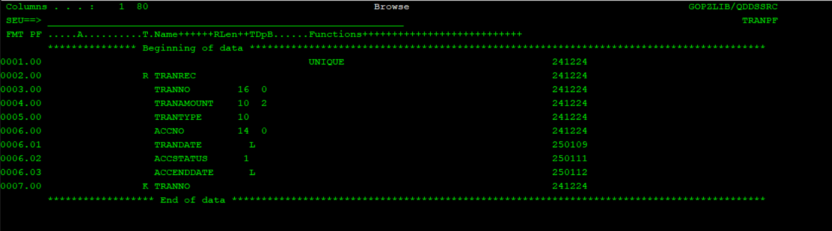

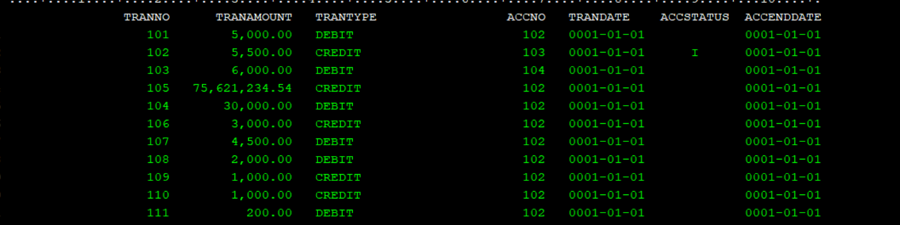

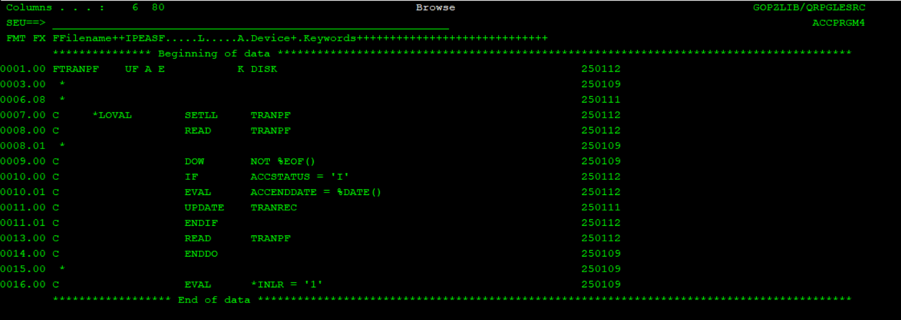

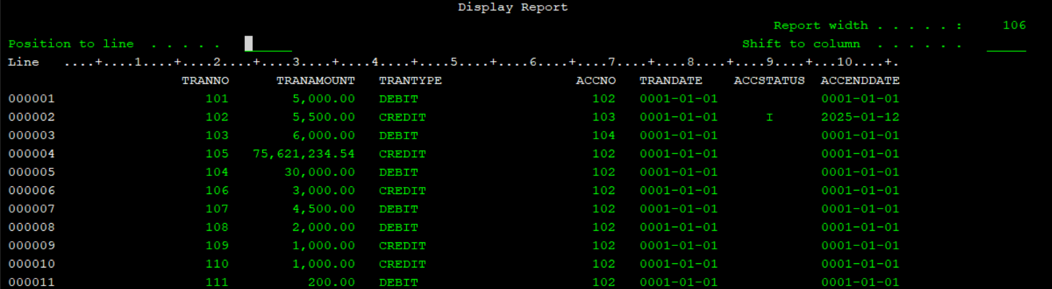

Question 2 : create a rpgle program to take employee city and parameter and display count of employees in that city,. Question

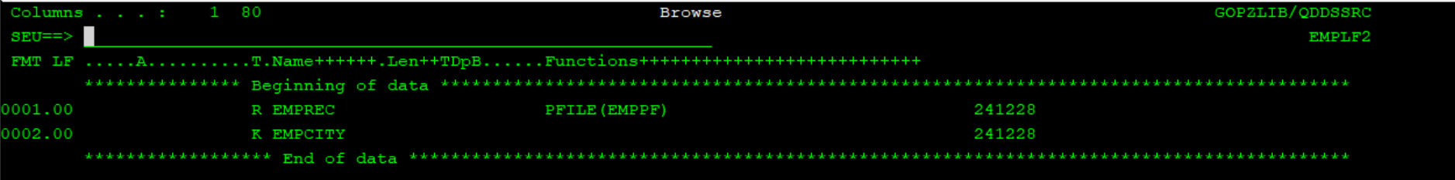

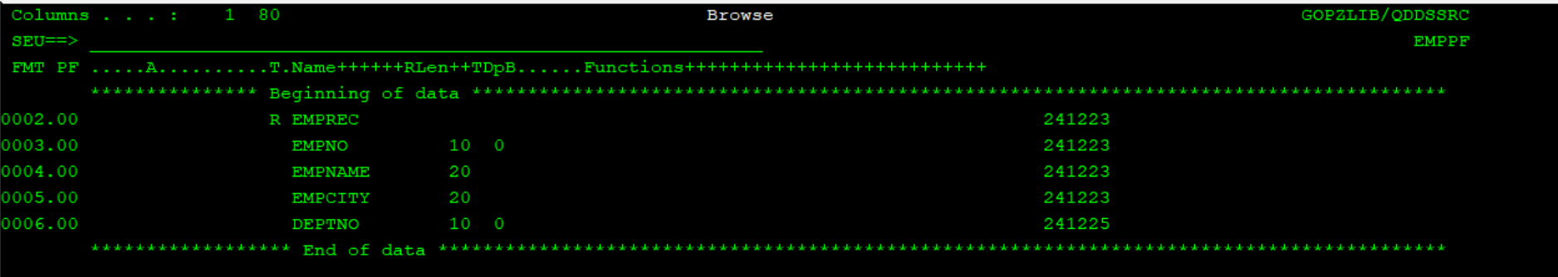

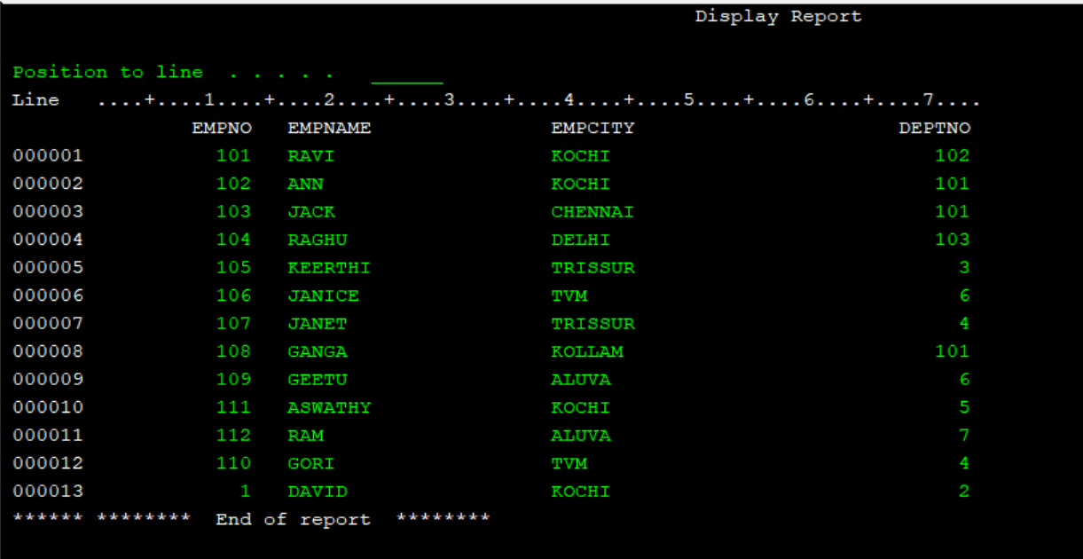

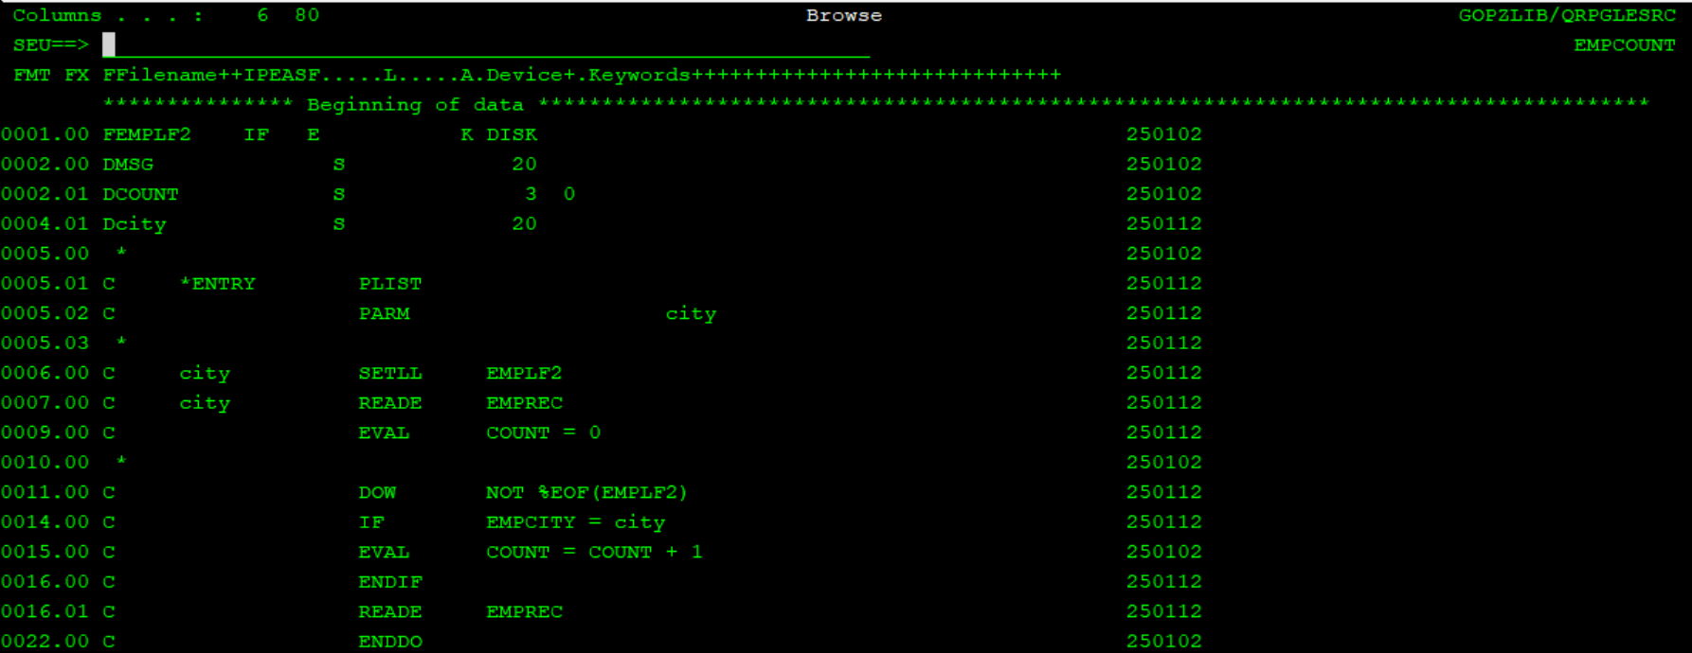

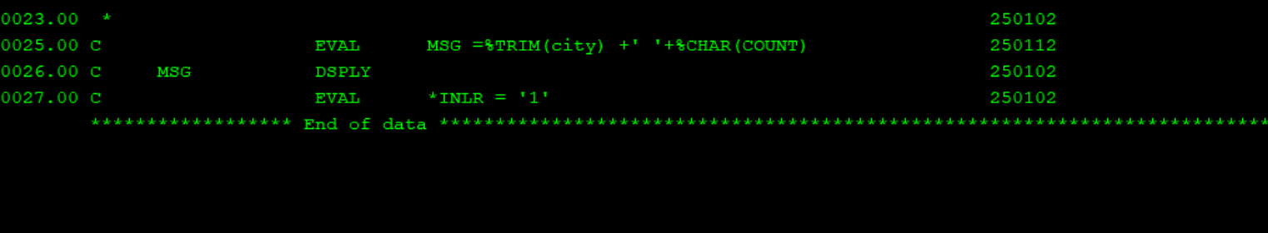

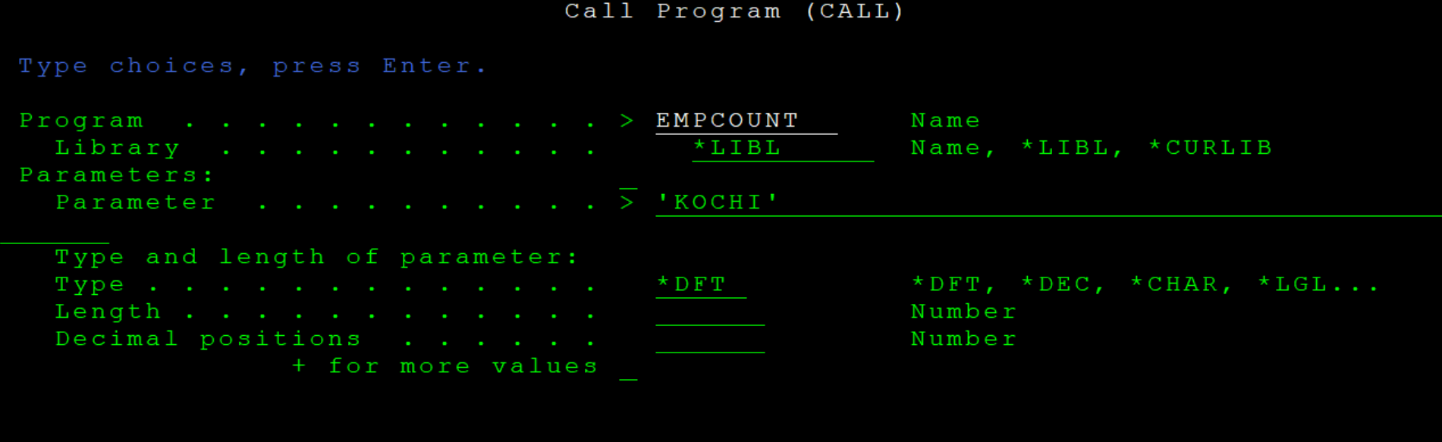



3: Create account entry program take acocunt no , name as input , other fields should be account opening balance(should be default to 100 ) and account opening date(should be default to current date)

